TEST-2
NAME:KAVYA.T
REG.NO: 1P25CS006.
CLASS: 1ST MSC CS

PROGRAM-1[WORD COUNT]

CODING:
<!DOCTYPE html>
<html lang="en">
<head>
<meta charset="UTF-8">
<title>Word Count</title>
</head>
<body>

<script>

const words = (str) => {
return str.replace(/[.,]/g, "").split(" ");
};

const wordFrequency = (wordsArr) => {
const freq = {};
const uniqueWords = [...new Set(wordsArr)];

uniqueWords.forEach(word => {
freq[word] = wordsArr.filter(w => w === word).length;
});

return freq;
};

const text = "Hi , I am studying in rvscas in sulur.In school of computer studied PG. I completed my UG at KASC.";

const allWords = words(text);

const frequency = wordFrequency(allWords);
console.log(frequency);

</script>

</body>
</html>

OUTPUT:
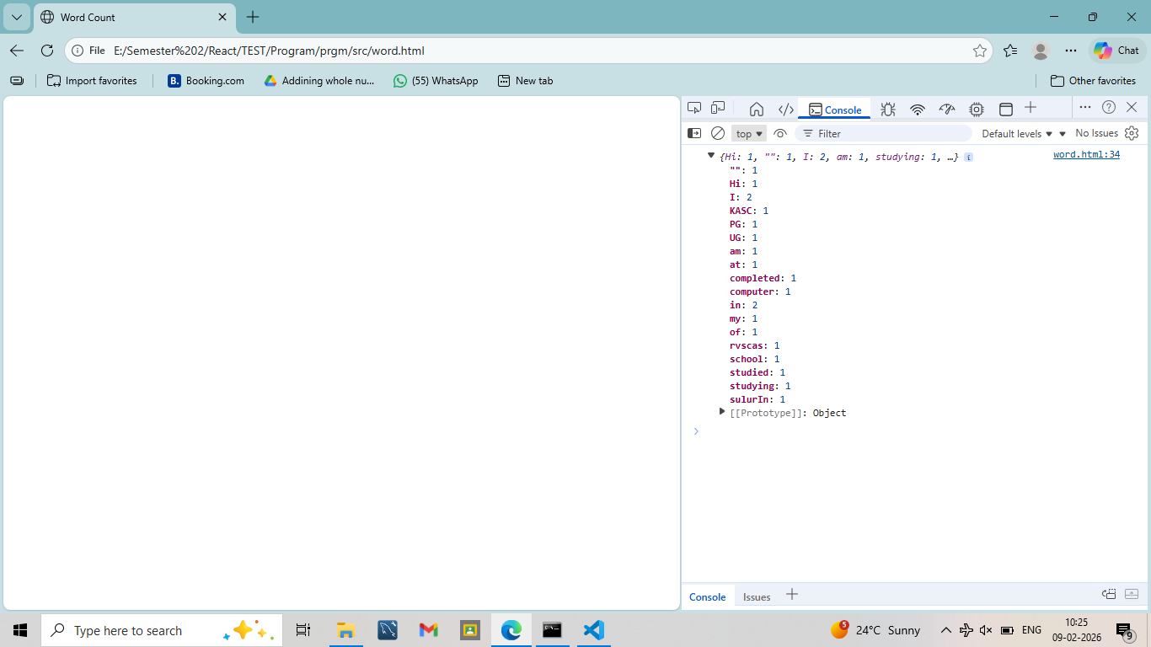

PROGRAM-2 [TODO LIST]

CODING:
import React, { useState } from "react";

function App() {
const [list, setList] = useState([]);

const addItem = () => {
const value = document.getElementById("item").value;
if (value === "") return;
setList([...list, value]);
document.getElementById("item").value = "";
};

const deleteItem = (index) => {
const newList = [...list];
newList.splice(index, 1);
setList(newList);
};

return (
<div>
<h2>TODO List</h2>

<input id="item" placeholder="Enter Item" />
<button onClick={addItem}>Add</button>

{list.map((item, index) => (
<div key={index}>
{item}
<button onClick={() => deleteItem(index)}>X</button>
</div>
))}
</div>
);
}

export default App;

OUTPUT:
